- Software Functional Modelling:

  - Use case model:
  - 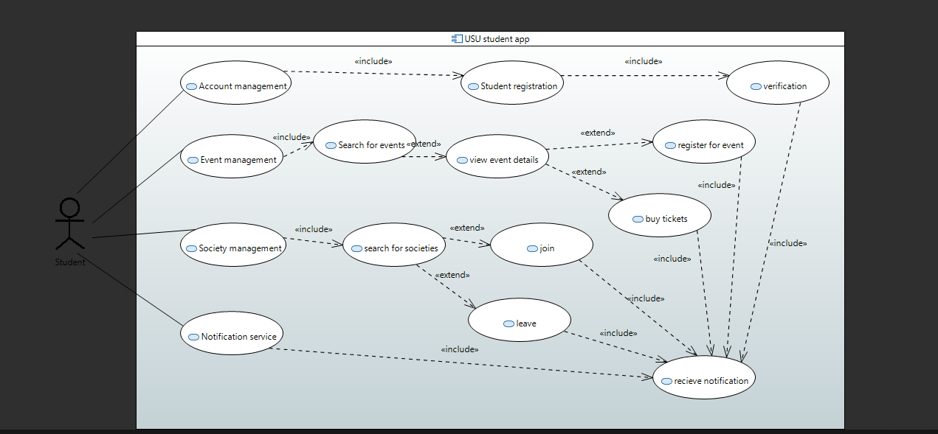

2.2. Activity model:
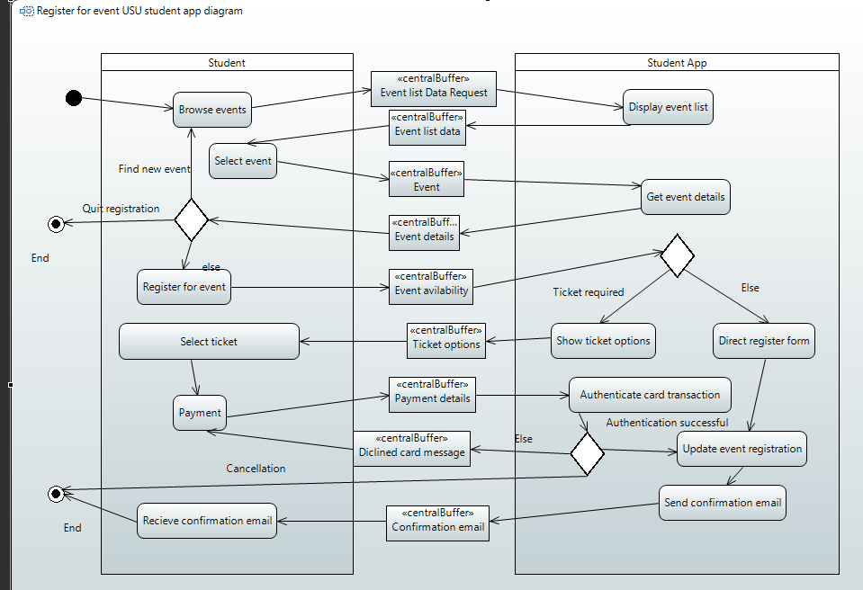

- Software architectural Design:

  - Architecture of the subsystem:
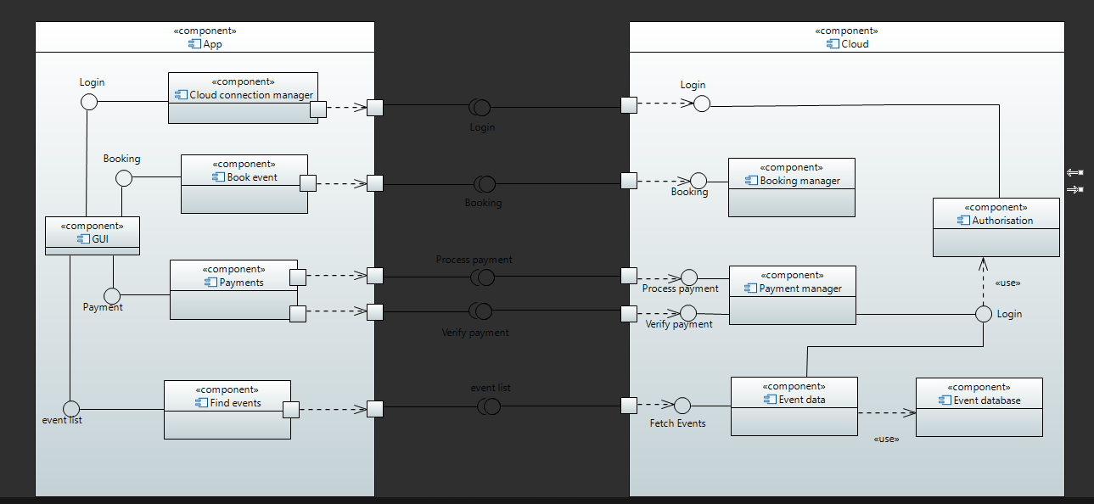

3.2. Specification of the components and interfaces:

Component | GUI
Description | Handles the display of every interaction within the student app
Stereotype | Component
Required interfaces | none
Provided interfaces | Booking, payment, login and events list

Component | Cloud connection manager
Description | This component handles authorisation within the app from the user.
Stereotype | Component
Required interfaces | login
Provided interfaces | login

Component | Book event
Description | This component runs within the app to handle the booking of students to events
Stereotype | Component
Required interfaces | Booking
Provided interfaces | Booking

Component | Find event
Description | This component is used to find the events that have been searched by the user.
Stereotype | Component
Required interfaces | Event list
Provided interfaces | Event list
Component | payments
Description | This component is used by the user to buy tickets that they are booking for
Stereotype | Component
Required interfaces | Payment
Provided interfaces | Process payment, verify payment

Component | Booking manager
Description | This gives the necessary forms for the user to fill out to book onto the event
Stereotype | Component
Required interfaces | booking
Provided interfaces | Authentication

Component | Payment manager
Description | This component checks the payment that the user has sent
Stereotype | Component
Required interfaces | Process payment, verify payment
Provided interfaces | Authentication

Component | Event data
Description | This component sends and receives the event data that the user is requesting or signing on to
Stereotype | Component
Required interfaces | Find events
Provided interfaces | none

Component | Authentication
Description | This is used by the subsystem for checking that the user is able to do the things that they are requesting, such as if they are eligible for the event they’re booking onto
Stereotype | Component
Required interfaces | login
Provided interfaces | login

Component | Event database
Description | This runs on the subsystem to handle the collection of users credentials that have booked onto the events and distribution of events for the purpose of booking onto them.
Stereotype | Database
Required interfaces | None
Provided interfaces | Event data

- Detailed Design:

  - Structural model:
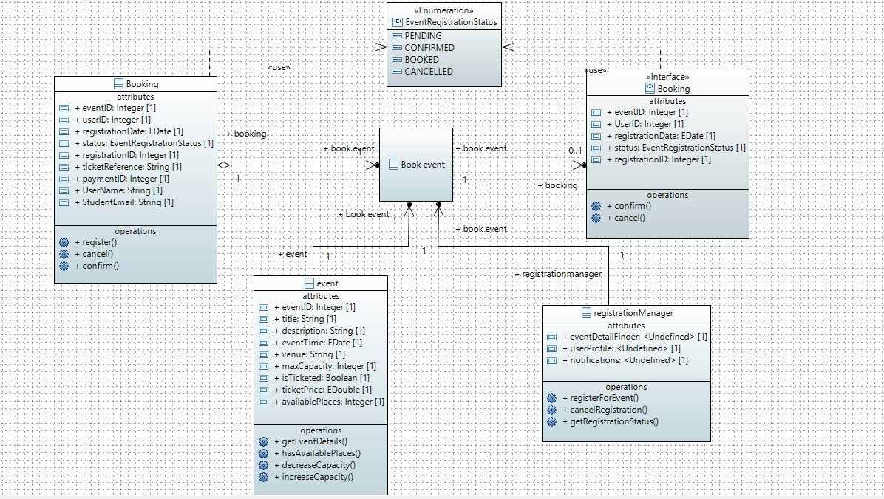
4.2. Behavioural model
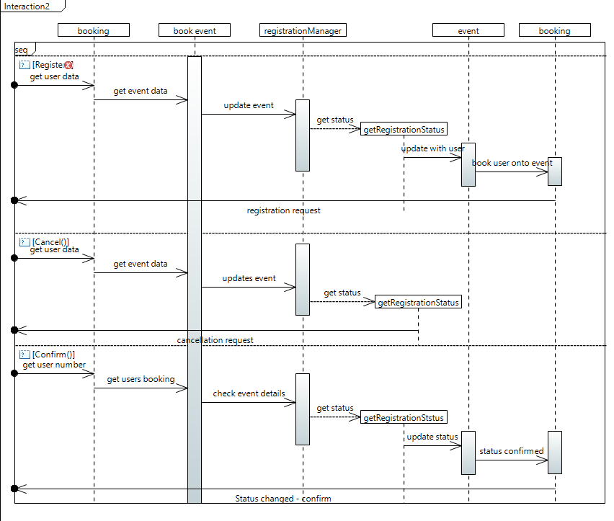

- Reflection on Teamwork:

Overall the coursework was manageable, with what we were given we managed well even when there were several major concerns within this coursework.

  - Contributions to team organisation and project management:
Our group meetings were weekly although not at the same time or day each week due to commitments of the members. We shared the progress of our work throughout the coursework and provided feedback especially in the starting weeks. The meeting minutes were then created and put into GitHub in which I was a part of every meeting. I didn’t create the github but was a big part in its organisation providing a readable layout in which members could upload their work.

5.2. Technical contributions

We started off using the deadlines provided by the coursework for each week until other coursework’s due dates came around in which we fell behind relying on my extension. I created a few drafts of each task using draw.io and then when I was happy with it used papyrus to create the final product. In the earlier weeks we documented our support for each other a lot more within the group meetings, but as the weeks went on it became more so in the WhatsApp group that we created. Giving feedback there instead of within the meetings

